LORETO CONVENT SCHOOL TARA HALL
CBSE CLASS X TOPPERS 2025-26

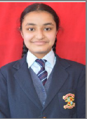 ARUNDHATI SHARMA = 98 %

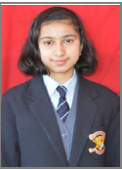 VIBHUTI KAPRATE = 97.6%

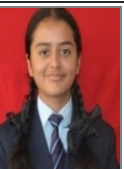 MEHAK RANA = 97.4%

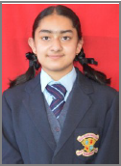 VAANYA BALI = 97.4%
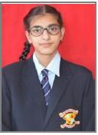 AJOONI KAUR = 97%

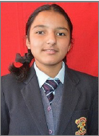 SAMAIRA = 96.8%

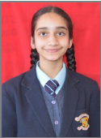 AALIYA KUKREJA = 96.6%

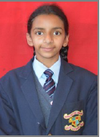 MANYA VAID = 96.6%

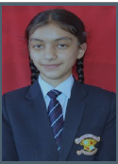 ANANYA THAKUR = 96.6%

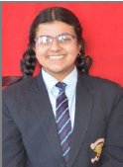 KASHVI GUPTA = 96.2%

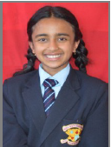 SAVANI DOGER = 96.2 %
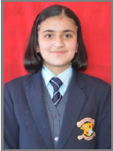 NAVYA BANTA =95.8%

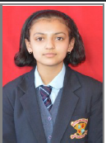 AVANTIKA = 95.6%

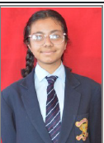 MANVI CHANDEL = 95.6%

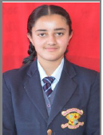 SAMAYRA KARROW = 95.6 %
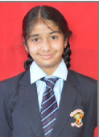 ZOYA KHAN = 95.6%

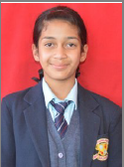 OJASVI SINGH TOMAR = 95.4%

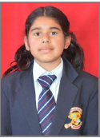 DIKSHITA KALSAIK = 95.4%

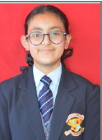 AISHANI VERMA = 95.4%

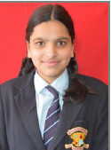 SAANVI SHARMA= 95.2%

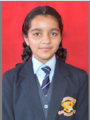 ANAHITA SINGH THAKUR = 95%

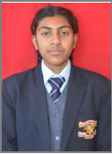 JENNIFER = 95%

