LORETO CONVENT TARA HALL SHIMLA CBSE RESULT CLASS 12
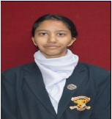 AKSHITA THAKUR 99.2%
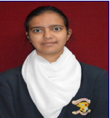 SHREYSI SHARMA 98.8%
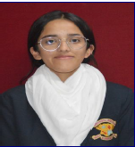 AAMVI NEGI 97%
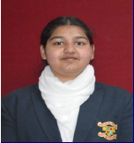 PRANJALI DEWAN 94.8%
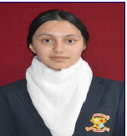 TRIVENI JHAGTA 94.4%

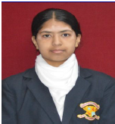 SAANVI SOOD 94%
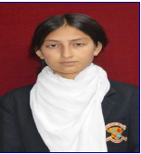 VIKHYATI KANWAR 93.8%
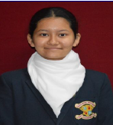 APURVA NEGI 93.6%
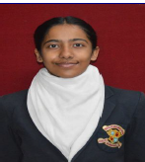 SANVI SOOD 93%
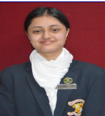 KATYAYNI SHARMA 92.8%

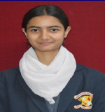 AAMIN CHAUHAN 92.4%
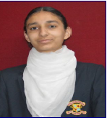 SUPRIYA SHARMA 92%
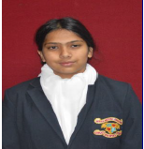 ARNIMA SHARMA 91.6%
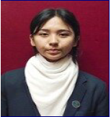 AVANI THAKUR 91.6%
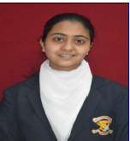 RABHNOOR SANDHU 91.2%
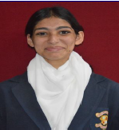 KRISHMA BANSAL 91.2%

