LORETO CONVENT CBSE RESULT CLASS 12

TOPPERS OF SCIENCE STREAM

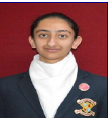 PRAKRITI GULARIA 88%

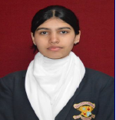 PRISHA THAKUR 86.8%

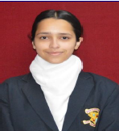 ANANYA SOOD 85.8%

Toppers of Commerce stream
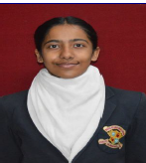 SANVI SOOD 93%

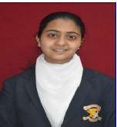 RABHNOOR SANDHU 91.2%

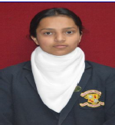 TARUSHI RANA 91%

Toppers of Humanities

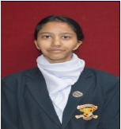 AKSHITA THAKUR 99.2%

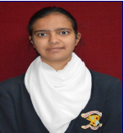 SHREYSI SHARMA 98.8%

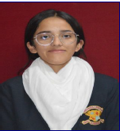 AAMNI NEGI 97%

